BY -35 days Team Entry

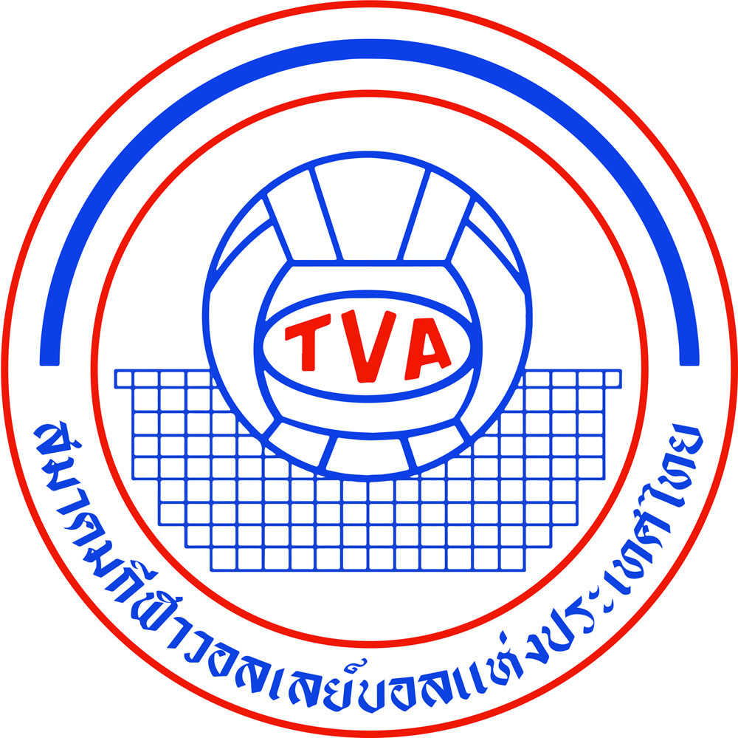

AVC Beach Tour 25th Samila Open
12-15 April 2026

This form must be sent to the organizer (and copy to AVC) by March 8, 2026 by email.
Each Federation can enroll two teams (2) teams plus one reserve team per gender. Host can enroll three (3) teams plus one reserve team per gender.

***IMPORTANT***
The National Federation must both submit the entry form and enter the below teams in the Volleyball Information System (VIS) www.fivb.org/vis as per the regulations.
Otherwise, the teams will not be eligible to participate in the event.
If the federations have any problems in register teams in VIS system, please contact
AVC Beach Department for further assistance.

WOMEN
TEAM | LAST NAME | FIRST NAME | FIVB ID # | SHIRT NO. / SIZE | TEAM CAPTAIN | NF
1
2
3
(Host only)
Reserve

MEN
TEAM | LAST NAME | FIRST NAME | FIVB ID # | SHIRT NO. / SIZE | TEAM CAPTAIN | NF
1
2
3
(Host only)
Reserve

Note: Team with the most points will be Team 1. If equals, depends on coach’s decision.
Note 2: If the Main Draw is not full (less than 24 teams) The reserve team from Host and the reserve team(s) with the most entry points as of -35 days among all participating NFs’ reserve teams will be selected to fill the Main Draw.

TEAM OFFICIAL OR COACH

 | LAST NAME | FIRST NAME
TEAM OFFICIAL/COACH 1
TEAM OFFICIAL/COACH 2

PROPOSED ACCOMPANYING REFEREES

• One accompanying referee MAY be nominated by NFs entering 2 teams in AVC Beach Tour.
• The names and number of accompanying referees should be approved by AVC in advance.

LAST NAME | FIRST NAME | UNIFORM SIZE

NATIONAL FEDERATION  AUTHORISED SIGNATURE | SEAL OF THE FEDERATION | PLACE AND DATE
……………………………………

